**Activity #3 (Midterm)**  
  
  
1.  Arithmetic expressions that may contain various pairs of grouping symbols, such as:  
**Parentheses**: “(“ and “)”        
**Braces**: “{“ and “}”    
**Brackets** “[“ and “]”  
Each opening symbol must match its corresponding closing  
symbol. For example, a left bracket, “[“ must match a corresponding right  
bracket, “]”, as in the expression [(5 + x) – (y + z)]. The following examples  
illustrate this concept:  
  
**Correct**: ( )(( )){([( )])}     
**Correct**: ((( )(( )){([( )])}))     
**Incorrect**: )(( )){([( )])}  
**Incorrect**: ({[])}  
**Incorrect**: (

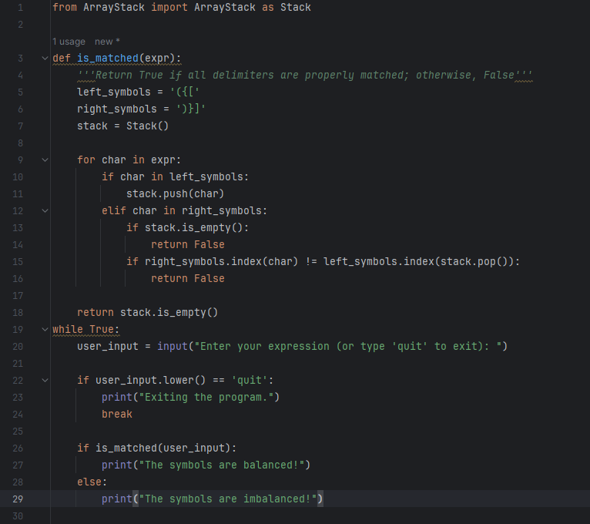

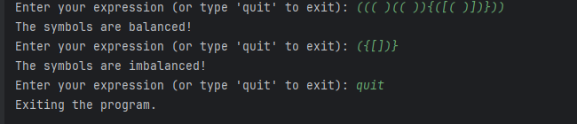

2. Create a program that reverses the lines of text of a  
file using a Stack Data Structure. After executing the program, the **text  
file**have text which are reversed by the Stack.

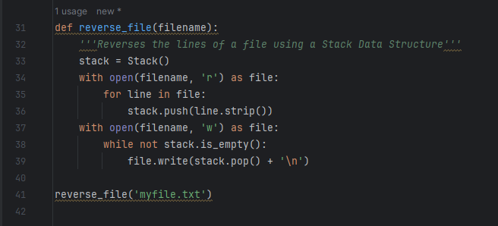

ORIGINAL:

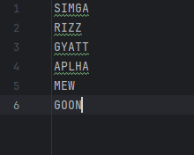

REVERSED:

